Examine the Impact of Gamification on Facebook Users

-Submitted by Heet Shah, Anuj Vengurlekar, Sheau Kwan

**Table of Contents:**

|  |  |  |
| --- | --- | --- |
| Sr. No. | Title | Page No |
| 1 | Abstract | 2 |
| 2 | Introduction | 3 |
| 3 | Research Objectives | 5 |
| 4 | Literature Review | 5 |
| 5 | Methodology | 7 |
| 6 | Data Characteristics | 8 |
| 7 | Objective 1 | 10 |
| 8 | Objective 2 | 16 |
| 9 | Objective 3 | 18 |
| 10 | Weaknesses & Limitations | 21 |
| 11 | Concluding Remarks | 21 |
| 12 | References | 22 |
| 13 | Appendix | 23 |

# Abstract

Social media has been a rage over the past couple of years, even though it is almost 20 years[1]. On an average globally, internet users spend 126 minutes a day every day on social media[2]. Of all the social media channels present in the world, Facebook is the largest social media website by number of active users.

Our research is restricted to Facebook, which is the most popular social network worldwide[3]. As of the third quarter of 2018, Facebook had 2.27 billion monthly active users. In the third quarter of 2012, the number of active Facebook users had surpassed one billion, making it the first social network ever to do so. Active users are those which have logged in to Facebook during the last 30 days. Furthermore, as of the previous quarter the [social network had 1.74 billion mobile MAU](https://www.statista.com/statistics/277958/number-of-mobile-active-facebook-users-worldwide/).

Of late, the past couple of years, people have been spending less and less time on Facebook[4] while Facebook wants people to spend more[5]. This has led Facebook to try out new features and new techniques to keep people engaged. One of the techniques is gamification, which is the use of game-type elements within a non-game environment. This technique has been used by a lot of companies in lot of different industries.

So, our purpose of the research was to understand how Facebook employs gamification among its varied set of new features and how it can be effectively applied to a cluster of users on the website to efficiently apply those features. The reason we chose this topic is because although Facebook has been around for quite some time and Facebook users have different behavior to these different behaviors as has been shown in previous research, there is no research to link the new and upcoming gamified features to these users based on their behaviors. So, we wish to link these the users and the features for 2018 and contribute a data-backed strategy that explains the phenomena.

# Introduction

Social media is an umbrella term for a set of web-based applications and services where users create and exchange self-made content (Kaplan & Haenlein, 2010). Kaplan and Haenlein propose that social media can be categorized into six categories based on their level of social presence and self-presentation. The categories in the classification are blogs (e.g. Twitter, Blogger), collaborative projects (e.g. Wikipedia), social networking sites (e.g. Facebook), content communities (e.g. YouTube), virtual social worlds (e.g. Second Life) and virtual game worlds (e.g. World of Warcraft).

We will be focusing our study on social networks. Social network penetration worldwide is ever-increasing. In 2017, 71 percent of internet users were social network users and these figures are expected to grow. Social networking is one of the most popular online activities with high user engagement rates and expanding mobile possibilities[6] (eMarketer, 2018).

As social networking keeps growing, there is an increasing need by these companies to keep the users engaged & satisfied. As pointed out by Jakob Nielsen,“In most online communities, 90% of users are lurkers who never contribute, 9% of users contribute a little, and 1% of users account for almost all the action.”[7] So, if there are too few active contributors then the online community will struggle in staying sustainable. So, the tactics that have enabled the social networks to grow so far are quickly getting outdated as the competition rises and its very easy to switch between different social networks on the web. One of the ways to keep people engaged is via gamification[8][9].

Gamification refers to the “use of game design elements within non-game contexts”[10]. The central idea is to take the ‘building blocks’ of games, and to implement these in real-world situations, often with the goal of motivating specific behaviours within the gamified situation. Many authors see gamification as an innovative and promising concept that can be applied within a variety of contexts ([Werbach and Hunter, 2012](https://www.sciencedirect.com/science/article/pii/S074756321630855X#bib73), [Zichermann and Cunningham, 2011](https://www.sciencedirect.com/science/article/pii/S074756321630855X#bib78), [Zichermann and Linder, 2013](https://www.sciencedirect.com/science/article/pii/S074756321630855X#bib80)). This is why implementation of gamification in real-life situation is not seen as something unreasonable ([Rigby & Ryan, 2011](https://www.sciencedirect.com/science/article/pii/S074756321630855X#bib54)).

Nonetheless, when discussing gamification, it should be noted that it involves the game design elements rather than playful design, which often lacks structure, goals, or both (Groh, 2012). In terms of what the “non-game contexts” are, Deterding et al. (2011) suggest not to limit the definition any further as it does not provide any advantage to make such restrictions.

Gamification has been around since quite a few years[11] (Google Trends) and there have been numerous research studies already conducted on whether it works or not[12] (Hamari, Koivisto & Sarsa), its different applications in education (Huang & Soman, 2013; Hakulinen, Auvinen & Korhonen, 2013; Muntean, 2011), risk management (Bajdor & Dragolea, 2011), solving usability issues (Saha, Manna & Geetha, 2012) and marketing (Tillström, 2012), etc.

The results of some of these papers show that gamification does not automatically lead to great increases in engagement with the service but some of the most gamified users had increase in activity. (J.Hamari) Although empirically the majority of studies indicate more positive than negative or null effects of gamification on motivation, the evidence base on its effectiveness is still lacking due to limitations of study design and analysis strategies ([Hamari et al., 2014](https://www.sciencedirect.com/science/article/pii/S074756321630855X#bib31), [Seaborn and Fels, 2015](https://www.sciencedirect.com/science/article/pii/S074756321630855X#bib64)).

Gamification has been popularly used by marketers and product managers to engage customers and influence desirable usage behavior.9,10,14 For example, DevHub (www.devhub.com) succeeded in increasing the number of users completing online tasks from 10% to 80% by adding gamification elements such as points and levels.45 Engagement metrics like time spent on site was raised by 20% as compared to that before the application of gamification techniques.14 A New York-based food ordering website, Campusfood.com, experienced a 15–20% increase in the return of new users after adding points and badges features to their site.46 Other popu- lar examples of raised user engagement driven by game techniques can be seen in various online applications such as eBay (ebay.com), Foursquare (foursquare.com), LinkedIn (linkedin.com), Livemocha (livemocha.com), MeYouHealth (meyouhealth. com), PracticallyGreen (practicallygreen.com), Khan Academy (khanacademy.org), to name a few.9,47

There was a study on how gamification motivates to study the effect of game design elements on psychological need satisfaction where they applied self-determination theory framework in the context of gamification. The results showed that badges, leaderboards, and performance graphs positively affect competence need satisfaction, as well as perceived task meaningfulness, while avatars, meaningful stories, and teammates affect experiences of social relatedness. Perceived decision freedom, however, could not be affected as intended. They interpreted those findings as general support for our main hypothesis that gamification is not effective per se, but that specific game design elements have specific psychological effects.

This research paper aims to understand the impact of gamification features on different types of Facebook users. There have been numerous studies in the past linking gamification to social media[13], but they tend to be exhaustive as they combine numerous services under an single umbrella of social media and extrapolate the results of gamification to all the services that have related elements.

It is in the interest of our research to focus our study on only one social network platform, which happens to be the most popular one on the web today and to identify game-related elements in 2018 and make inferences based on user activity of those elements. There are a lot of users on facebook, but it is known that not all of them engage with the service in the same way as per numerous studies in the past[14].

1. Research Objectives

The study uses the approach for analysis done by previous research. However, since in the previous studies, the social networking websites have seen tremendous changes, as well as, the fact that there has been a significant rise in the number of active users on the website. Due to this, the previous research has become outdated. Thus, in order have a comprehensive understanding of applications of gamification in social media**, our research has been divided into 3 main objectives:**

1. To cluster Facebook users based on their type of activity performed on the website and their amount of engagement with its features.
2. To link Facebook’s latest features with game-type elements into appropriate buckets of features to assess psychological & web engagement impact.
3. To recommend engagement strategies based on user clusters and gamified Facebook features that could have positive impact in engaging & sustaining users.

# Literature Review

Gamification has been extensively researched in the past couple of years. According to the works of Hamari, Koivisto & Sarsa (2014), there were almost 8050 papers found on gamification on the web back in 2014, since then the number has obviously increased.

One of the earliest research on gamification in social networks goes back to a paper by Bista, Nepal, Paris & Colineau (2014) where they decided to introduce gamification in an online community that they designed and developed with the Australian Government's Department of Human Services to support welfare recipients transitioning from one payment to another. While they didn’t really comment on gamification to drive engagement, but they gave an initial look at gamification design in an online community context and its instantiation.

Since the paper’s objective was to drive welfare payments, all members had to be treated equally and use of games per say was not appropriate. They defined a gamification model (a seven tuple model) based on member’s actions in particular contexts, based on which points were assigned & gamification elements were assigned based on points. The study primarily focused on badges. The study was trialled for 1 year with welfare recipients as participants (around 181 members with data from weeks 6 to 47). Since the paper could not measure whether gamification drives user engagement, they found that gamification introduced enabled them to obtain accelerated feedback on the life in the community, providing them with a useful abstraction level over the raw data.

The above paper was an extension of an earlier work with the same authors (2012) where they outlined the problems in establishing a new online community has three challenges that can be engaged with gamification: bootstrapping, monitoring, and sustainability. Bootstrapping refers to the process of gathering initial members to the community and keeping them engaged during the initial phase. Monitoring refers to the process of observing the usage of the service. Finally, sustainability refers to the problem of sustaining the user engagement after the initial phase. One of the limitations of the study was that it only covered monitoring aspect and not bootstrapping or sustainability. Also, due to design constraints like equality and no penalty, there were limitations on gamification elements that could be employed.

Another paper by Antin & Churchill (2011) focused on badges in social media: a social psychological perspective where they said badges are a “key ingredient” in gamifying social media experiences. They give examples of Wikipedia, StackOverFlow & Foursquare & deconstruct badges as 5 social psychological functions: goal setting, instruction, reputation, status/affirmation, and group identification.

The notion of conceptual consumption is essential to understanding badges because, of course, ultimately the user is left with no physical goods, only the experience and memory which is embodied by a badge. Badges can help signify reputation in place of describing direct experience, they can serve as status symbols, they can also communicate a set of shared activities that bind a group of users together around shared experience. One of the key limitations of the study is that the social psychological functions that it takes into account is not an exhaustive list but based on research of some past research papers done as well as the fact that there is no experiment done to verify those functions. The functions are inferred as implemented based on some real-life examples but the paper mentions that there are counter-arguments for their benefits as well as the positive impact that it showcases, it boils down to the fact that badges might only work in some contexts.

Bunchball12 outlines possible six human desires (shown in Fig. 1) that a gamification model can target to motivate and engage users.

The impact of a point-based incentive system in a company-internal social net- working site was conducted by Frazan et al.51 Their results show the positive impact of incentives in motivating staff to contribute to the company’s social network. Thom et al.52 also studied the pattern of user activity after removing point-based gamification in an enterprise social network. Their findings demonstrate that remov- ing gamification from the enterprise network had a significant negative impact in the amount of user generated content. These studies confirm the positive impact of gamification on user engagement.

# Methodology

In order to understand how gamification can be used to engage users on social media, we focused our approach on Facebook users. A survey was distributed online which was followed by a comprehensive cluster analysis identify various types on users on Facebook. Later, we performed affinity analysis to group different functionalities that Facebook has to offer into different gamification buckets.

Using the responses of the survey and customer profiles created using clustering, we were able to identify which gamification elements are more important to each of the user groups. Thus, by combining the results from affinity analysis and cluster analysis, we are can now identify which functionalities on Facebook may be attractive to the cluster groups and hence make recommendations on engagement strategies to Facebook for each user group

* **Participants:** An anonymous survey was conducted in November 2018. The survey was distributed online via Facebook, email and WhatsApp and we were able to collect 116 distinct valid survey responses. The respondents were mainly young adults belonging to age groups between 18 to 25 years (25%) and 26 to 35 years (57%).
* **Survey:** The survey was created in Qualtrics with 4 major sections. In all, the survey had 15 main questions with some questions consisting of sub parts. A copy of the complete survey can be found in the *Appendix*. The 4 sections were formed to address (1) the general information about the consumer such as what social media platforms are they active on and how many friends do they have on their Facebook account; (2) Frequency in which they use Facebook and their usage pattern; (3) Behavioral questions related to gamification factors and consumer psychology; (4) Demographic questions to capture information like occupation, education level, age group and gender of the respondents.

1. Data Characteristics

A total of 133 responses were initially captured. However, we used a screening question to determine valid respondents for the purpose of this research. The question was which social media websites have the consumer used before. If the respondent did not select facebook the their responses were not considered for analysis in this report. The following section shows a visual summary of users. List of Social Media websites the respondents have used before.

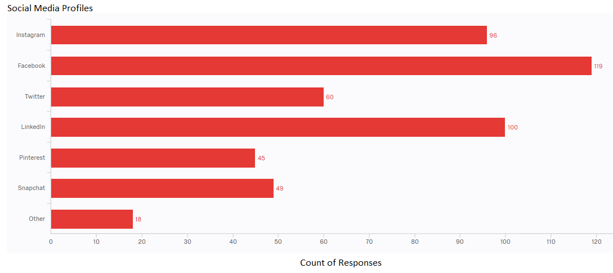

From the poll, we can see that Facebook was the most popular social media website followed by LinkedIn and Instagram.

**Distribution of Demographics**

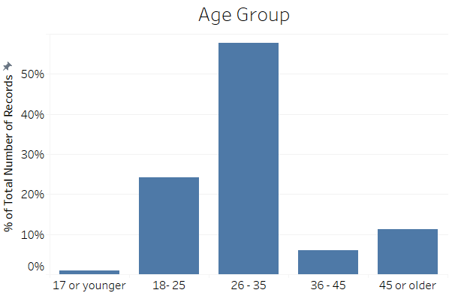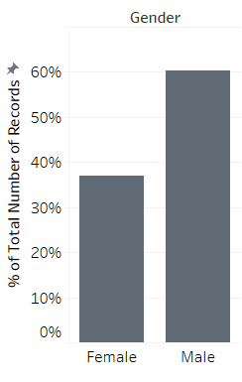

The 60% of the respondents were male and about 75% of the respondents were working full-time.

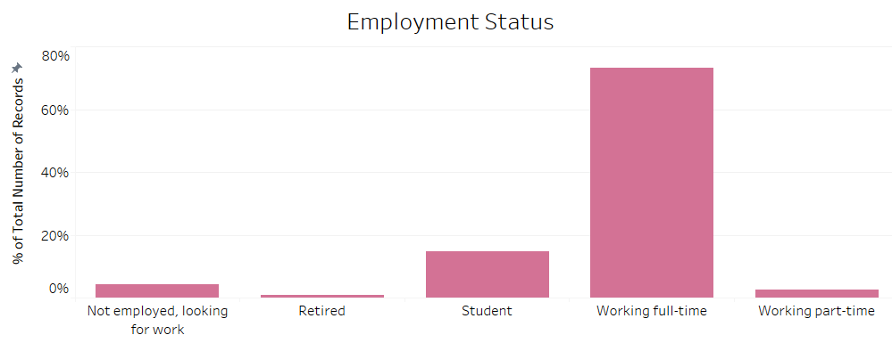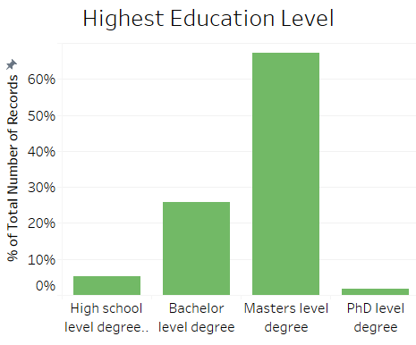

Distribution of number of friends, the respondents have on Facebook.

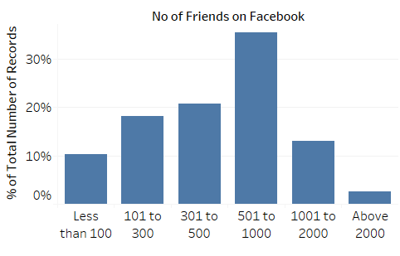

# Objective 1

In order to understand the profiles of the Facebook users, we conduct **Two Step cluster analysis** in SPSS using the responses from the section of the questionnaire that cover usage pattern of Facebook. These questions include three parts: (1) Frequency of uploading/posting (cover picture, display picture, video/picture, Facebook story); (2) Proportion of time spent on activities on Facebook (Interacting with friends, looking at curated content, networking, playing facebook games, looking at old pictures/albums and random scrolling through facebook wall) (3) Frequency of other activities on Facebook (tagging friends, getting tagged by friends, checking-in places, rsvp to events, playing games on facebook, posting a status)

For the purpose of the analysis, variables that were in interval and ordinal scale were converted into ratio scales. For example, the question *‘How frequently do you post a picture/video on Facebook?’* is on an ordinal scale with options (a) I do not use; (b) once in few months; (c) 3 to 5 times a month; (d) 3 to 5 times a week; (e) daily; These options were converted into ratio scales by assigning options the values 5, 25, 50, 80 and 100 respectively. By doing this, we will be able to identify the ‘closeness’ of the variables in clustering more effectively than in the case were the variable scale were nominal/ordinal.

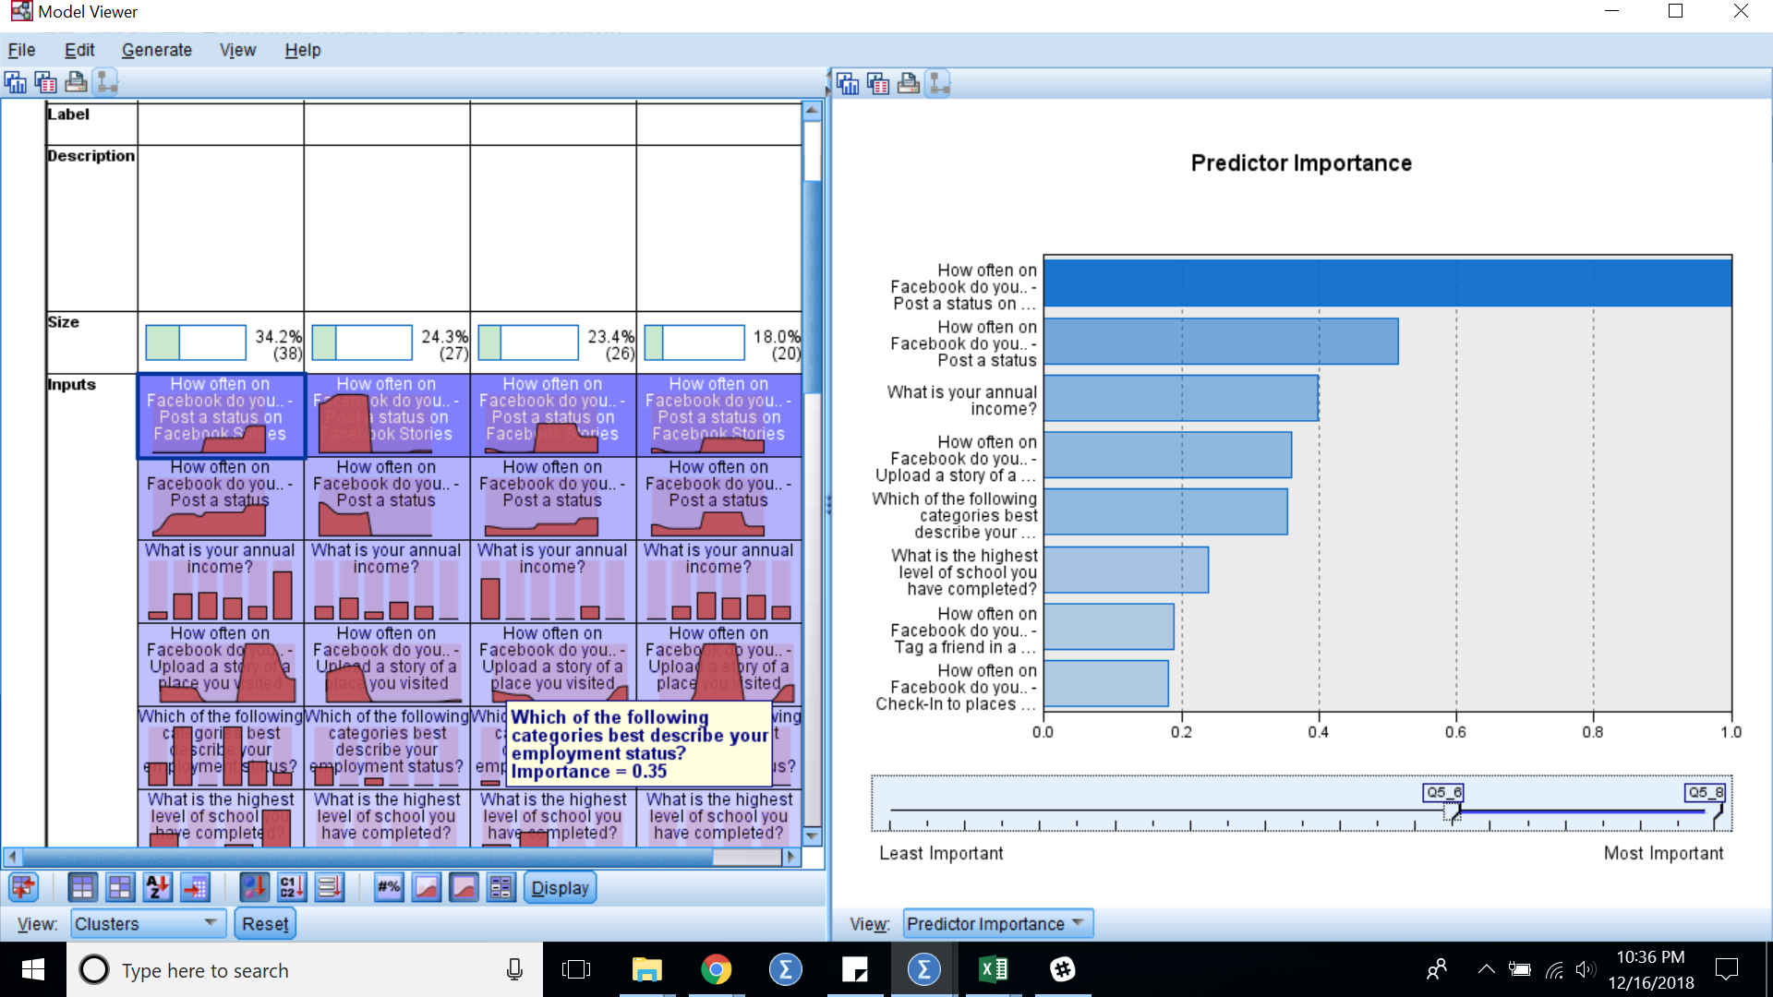

The above chart shows us how important each predictor is when we run the clustering analysis.

The following are the top 5 predictors in our clustering analysis:

1. How often on Facebook do you.. - Post a status on Facebook Stories
2. How often on Facebook do you.. - Post a status
3. What is your annual income
4. How often on Facebook do you.. - Upload a story of a place you visited
5. Which of the following categories best describes your employment status?

We used Two Step clustering analysis method to run our clusters. Two-step clustering analysis identifies groupings by running pre-clustering first and then by running hierarchical methods. Because it uses a quick cluster algorithm upfront, it can handle large data sets that would take a long time to compute with hierarchical cluster methods. In this respect, it is a combination of k-means and Hierarchical clustering. Two-step clustering can handle scale and ordinal data in the same model, and it automatically selects the number of clusters.[15]

After testing out for the best number of clusters to define, we find that the respondents in this survey can be grouped into 4 clusters to satisfactorily represent our dataset. We label the 4 clusters as (1) The Watchers (2) Youngsters (3) Social Butterfly (4) Professional Advocates

**Cluster 1: The Watchers** (25% of Respondents)

**Who are they:** Mainly males (70%), Working-full time (92%), Age groups 26 years and higher.

**Key Traits:** Low number of posts/uploads, Spend majority of time watching other’s posts and keeping in touch with family and friends. Most frequently in using Facebook.

**Description:**

This group comprises of people who responded that on average they spend about 70% of their time looking at old pictures/photo albums(Appendix 1d), interacting with friends and randomly scrolling through their facebook newsfeed (Appendix 1e). 82% of these respondents agree that it is important to know what is happening around them and 92% agree that it is important for them to spend time with family and friends. This group is labeled as watchers because this group has the lowest mean frequency of posts/uploads on facebook(Appendix 1a and 1b) , however out of all the cluster groups, this group spends the most amount of time on Facebook and have the second highest average number of friends on Facebook. Thus, although this group rarely post on Facebook(Appendix 1c), we see that they are yet the most active ‘watchers’ of people’s activity. Another noteworthy point to make is that this group spends the most amount their time (10%) playing games on Facebook as compared to other clusters (2% on average)

**Cluster 2: Youngsters** (24% of Respondents)

**Who are they:** Both Males (41%) and Females (59%), Age group is below 25 years, Mostly Students or unemployed and looking for job (80%) with bachelors as the highest education level (77%)

**Key Traits:** Present on multiple newer social media platforms like Snapchat, Pinterest, Instagram (90%), Average usage of Facebook features and not as active as other clusters

**Description:**

This group comprises on young individuals who use Facebook occasionally, mainly because they are present on multiple other social medias like Instagram, Snapchat and Pinterest. This group uses newer features of facebook like Facebook stories and RSVP to events more than other cluster groups(Appendix 2a). This maybe because of young adults are more technology friendly and are open to new features and also because these features are integrated with other apps. This group occasionally post a picture/video or change their display picture(Appendix 2b) and most times if they are on Facebook, they spend most of their time (~60%) randomly scrolling through the wall (Appendix 2c) or looking at curated content by brands.

**Cluster 3: Social Butterflies** (35% of Respondents)

**Who are they:** Both males and females (50% each), Mainly Age groups 26 to 35 years (65%), Working full-time

**Key Traits:** Spend most percentage of their time on Facebook interacting with friends (tagging and chatting) (Appendix 3a and 3b), Very frequent in changing profile pictures/ cover photos and uploading status updates on Facebook (Appendix 3c, 3d and 3e). Do not spend time looking at curated content or playing games. (Appendix 3f)

**Description:**

This group comprises on adults in their late 20’s and early 30’s who are very active on Facebook. They change their profile pictures and cover pictures once every few weeks. This group loves to tag and get tagged by their friends in memes and other posts. They actively post videos/pictures and upload facebook stories and RSVP to events. However, this group does not spend much time in looking at blog posts and other curated content.

**Cluster 4: Professional Advocates** (16% of Respondents)

**Who are they:** Males (100%), working professionals, Mainly Age group 26 to 35 years (79%)

**Key Traits**: Very active on facebook in terms of uploading pictures/videos(Appendix 4a), display pictures and cover photos, Spend most of their time on facebook looking at curated content(Appendix 4b), scrolling through their wall and networking (72%), do not spend much time in socializing or tagging people in posts (Appendix 4c). Has the most number of friends (on average 1000+) amongst all other cluster groups. (Appendix 4d)

**Description**

This group comprises of individuals who interact with brands and facebook groups a lot on Facebook and treat Facebook as a networking site as well. This group is very active in terms of keeping their profiles updated and posting about the places they visit and other activities they perform on Facebook stories. This group is mainly working male professionals who rarely spend their time on Facebook in tagging others in memes or interacting with other friends.

**Common Traits among the 4 cluster groups**

In our survey, we asked several behavioural questions and questions related to respondent’s activity on facebook. Responses to some questions stood out to be commonly important regardless of the cluster. (1) All the clusters indicated that although evening/night is a popular time to post on Facebook, but at most times they would post whenever they feel like; (1) All the clusters rated that it is very important for them to have their own personal space (privacy on Facebook) ; (3) All the clusters except for the ‘Watchers’ indicated that they do not spend time playing games on Facebook.

1. **Matching Gamification elements to clusters**

In the survey, the along with the questions related to activity and usage of Facebook, respondents were also asked behavioural questions related to gamification traits. Based on the responses to these questions and the clustering performed in the above section, we tried to associate which game like elements are the most important to these clusters

**The Watchers**

Primary Elements: Meaningful Stories, Teammates

Secondary Elements: Performance Graphs, Lonewolf

The Watchers are an active group of facebook users, who are distinctly known for being active without actually posting/ creating any content on the website. They spend majority of their time scrolling through old pictures/ wall and interacting with their friends. They really prioritize spending time with their family & friends as well as being updated about what is happening around them. The reason we recommend meaningful stories for this group is that as they scroll through the different photos/ videos, it would be great for Facebook to give them a feature that makes this easier for them in form of a curated video with a collage of photos or place where they can see them all at an instance. Also, since they do interact with people on the website, teammates is an ideal element that Facebook can use for this group.

Secondarily, lone wolf is a bucket that doesn’t really want to be in the limelight/ gain attention by posting on the website. So, some elements from lone wolf can be applied here as that matches the behavior of this cluster.

**Youngsters**

Primary Elements: Teammates, Badges

Secondary Elements: Avatar, Lonewolf

The youngsters are a group of people who are active on many more social media platforms than just Facebook. They are moderately engaged on the platform but their share of time is majorly divided among a lot of other platforms as well. The best way to get these people more engaged is by getting other people from the same demographic to be active on the website. This can be done using gamification features like teammates that engage a lot of users at the same time as well as badges to encourage them as they engage more. A good example of this could be the increasing popularity of “Snapchat streaks” which are just merely number of times a user has snapped back & forth with a particular person within a certain time period.

**Social Butterflies**

Primary Elements: Teammates, Meaningful Stories, Performance Graphs

Secondary Elements: Leaderboards, Points

The social butterflies are a group of people who are quite active bunch interacting with friends, tagging them as well as uploading photos/ videos. Since this group with quite socially active on the network, we thought it would be best to promote elements from teammates or meaningful stories to showcase their memories in a certain time period. Performance graphs enable users to see how they have been performing or rather how far they have come in life via social media through their pictures or events to highlight their achievements in life.

**Professional Advocates**

Primary Elements: Leaderboards, Badges,

Secondary Elements: Avatar, Lonewolf

Professional advocates are an unique group of people who are similar to cluster 3 in demographics but very distinct from them in terms of their behavior and activity on the website. In the behavioural questions, this user group is rated high on competitiveness and they desire to be at the top of the leadership boards. Professional advocates are known for using lot of the features that facebook provides (new as well as old) but the interesting aspect of their activity is that they don’t use these features for social purposes but rather to connect with other like-minded professionals like them. Professional advocates could, thus, be engaged more with elements like leaderboards, badges & meaningful stories to give them a sense of an incentive to stay engaged as well as help them connect with other individuals who have similar level of badges.

# VIII. Objective 2:

Gartner15 outlines four principal offerings of gamification that helps to drive engagement: (a) an accelerated feedback cycle, through the increased velocity of feedback loops, (b) clear goals and rules of play, through simple, user friendly and well defined goals, (c) a compelling narrative that encourages user participation and (d) challenging but achievable tasks offering thrill and enjoyment. The design of any gamification process should thus try to incorporate one or all of these principles.

To define game-like elements, Crawford's (2003) taxonomy can be used to say that any given game has elements that reflect its business purposes, is interactive, has goals, has competitors and allows attacks. Yet, the actual elements still remain unknown, and merely the properties of the elements are revealed by analyzing the taxonomy.

A distinction between game mechanics and game dynamics is made in Bunchball’s paper “Gamification 101” (Bunchball, 2010). In this paper, game mechanics are seen as actions, process and control mechanisms, while game dynamics are seen as compelling desires and motivations. As such, the definition of a game mechanic is similar to the definition by Hunicke et al (2004). However, the definition of game dynamics differ somewhat. Example of game mechanics given in the Bunchball’s (2010) include points, challenges, leaderboards, levels, virtual goods and spaces and gifts and charity. Similarly, examples of game dynamics include rewards, achievement, competition, status, self-expression and altruism.

Deterding et al. (2011) discuss the vagueness of the term “element” in the context of gamification. The authors note that neither a liberal approach – any element found in any game – nor a strict approach – elements that are specific to games – would not produce the required definition. Instead, the authors suggest that the term “gamification” should be restricted to “the description of elements that are characteristic to games”, meaning that the game-like elements are found in most games and are already associated with them.

In her paper, Muntean (2011) lists some of the various game mechanics used in gamification. These mechanics include points, levels, challenges, virtual goods, leaderboards, and gifting and charity. A larger list of examples of game mechanics is listed by Gamification.org (2014).

In this list, there are mentioned such mechanics as achievements, appointments, behavioral momentum, blissful productivity, bonuses, cascading information theory, combos, community collaboration, countdown, discovery, epic meaning, free lunch, infinite gameplay, levels, loss aversion, lottery, ownership, points, progression, quests, reward schedules, status, urgent optimism and virality. While 13 some of these mechanics are not mentioned by other sources, many of them, such as points, achievements, levels and progression are (Muntean, 2011; Avedon, 1971; Groh, 2012).

**Affinity Grouping of new features introduced by Facebook into gamification elements**

With the growing social media landscape in order to stay competitive and relevant, Facebook has always been evolving and introduces new features every single year. We have used affinity analysis to group the new features launched by Facebook since Jan 2015 to group them under different gamification elements. A brief explanation of each of the feature considered in this analysis can be found in the appendix below.

In our analysis, gamification has been broadly divided into the following elements: (1) Points (2) Badges (3) Leaderboards (4) Meaningful Stories (5) Avatars (6) Teammates (7) Lonewolf.

The affinity grouping of the new features of Facebook can be seen below:

|  |  |  |
| --- | --- | --- |
| Sr.no | Gamification Elements | New Features on Facebook |
| 1 | Points | Facebook Virtual Arcade, Featured facebook Watch Section (Curated videos), Facefilter games,Rising star, Make a Fundraiser |
| 2 | Badges | Conversation starter, Facebook Townhall, Facebook Virtual Arcade, Influencer Facebook Watch Section, Make a Fund raiser, Rising star, Top fan |
| 3 | Leader-Boards | Facebook Stories, Facebook Virtual Arcade, leader section on Facebook Watch Section, Facefilter games, Games in groups |
| 4 | Performance Graphs | Facebook Friendship viewer, Facebook Live new features (Popular streams), Facebook Memories, Facebook romance, Facebook Townhall, Recommendations Section (Groups/Events), Save posts for later, Facebook Moments |
| 5 | Meaningful Stories | Edit Ad Preferences, Facebook birthday calendar new features, Facebook Live, Facebook Memories, Facebook Live new features (Popular streams), Facebook Note, Facebook Watch Section (Curated videos), Interest List, Messenger day, Recommendations Section (Groups/Events), Save posts for later, See First |
| 6 | Avatars | Face Filters, Facebook Stories, Mood faces, Facebook Live |
| 7 | Teammates | Facebook Live, Facebook Memories, Face Filters, Facebook Stories, Mood faces, AI Chatbot support, Conversation starter, Facebook romance, Facefilter games, Find all photos liked by, Games in groups, Group Video Chat, Messenger day, See First |
| 8 | Lonewolf | Edit Ad Preferences |

# IX.Objective 3

**Engagement Strategies for Facebook Clusters**

Proposing engagement strategies to FB for each cluster

**Cluster #1**

* Cluster 1 consists of the Watchers. As previously mentioned, the best gamification bucket for watchers would be meaningful stories & teammates.
* Of all the elements in meaningful stories, the ideal elements for watchers would be:
  + Facebook memories: To remind them of all the photos/ videos from a particular time period so that they don’t have to manually go back on their own or their friend’s profile to see past post of a certain day years ago. This will enable quick sharing if not on post but via messaging as they interact with their friends and increase engagement.
  + Facebook calender: To look for specific events like birthdays or other events that will enable them to connect with the right people right away or to look at relevant profiles or photos pertaining to those events.
  + Save posts for later: To enable them to look at posts later when they have the time or if they want to look at it again.
* Of all the elements in teammates, the ideal elements for watcher would be:
  + Facebook memories as mentioned earlier with features that enable easier sharing via messages or posts.
  + Facebook stories: So that they can remain updated on what’s happening around them or the social life of their friends & family.
  + Group video chat: To enable easier conversation flow among multiple friends.
  + Messenger day: Messenger day has similar USP to snapchat where messages and content shared disappears after 24 hours which could be a great feature for watchers as they prefer to not stay in the limelight and prefer privacy.
  + Find all photos liked by: So they can relate better with similar content from friends.

**Cluster #2**

* Cluster 2 consists of the youngsters. As previously mentioned, the best gamification bucket for youngsters would be teammates and badges
* Of all the elements in teammates, the ideal elements for youngsters would be:
  + Facebook live: To enable them to share live experiences in their life like concerts and engage live with their friends.
  + Face filters / Face filter games: Taking into account features that popular on other platforms, face filters is something that facebook can really double down on to get on par with Snapchat, Instagram & Tik Tok
  + Facebook stories: Again taking into account other platforms, stories are a big part of the latest social networks among teenagers and it is great that Facebook has made it easier for Instagram users to automatically share it on Facebook so they can transition easily. Since teenagers prefer to share their stories with only their own friends and not family, it would be better if Facebook can provide a way to filter the stories only to certain audiences.
* Of all the elements in badges, the ideal elements for youngsters would be:
  + Top fan: Top fan is a badge given to users who are particularly very engaging (likes, comments, shares, etc.) with a particular page/ brand. As we know from above that youngsters tend to go through a lot of curated content these badge can serve as an incentive to stay engaged.
  + Conversation starter/ Rising star: This is another badge that is just recently started by facebook in groups to enable different types of users in particular groups have different badges based on their activity.
  + Facebook watch section: Facebook watch collects curated content across the website similar to discover feature on Snapchat and Instagram so it can push content that users might actually be interested in to engage more.

**Cluster #3**

* Cluster 3 consists of the social butterflies. As previously mentioned, the best gamification bucket for social butterflies would be teammates, meaningful stories & performance graphs.
* Of all the elements in teammates, the ideal elements for social butterflies would be:
  + Facebook stories: Facebook stories will enable this cluster to stay up-to-date on the happening arounds of their friends and social circle.
  + Group Video chat: This will enable them to interact with multiple people at the same time in different social circles.
  + Messenger day: This feature is for those butterflies who prefer privacy and have similar traits to watchers.
* Of all the elements in meaningful stories, the ideal elements for social butterflies would be:
  + Facebook calendar: This will remind them of important events, birthdays, anniversaries coming up and get in touch with relevant people to maintain their relationships.
  + Facebook live: This will allow them to share live experiences with additional features so that only certain groups of people can see.
  + Recommended groups/ events: This will act as an engaging tool to enable the butterflies to participate in events/ groups that are similar to the ones they have participated in the past and would be interested again. This can be done using Facebook’s Machine learning algorithm.
* Of all the elements in performance graphs, the ideal elements for social butterflies would be:
  + Facebook friendship viewer: This is an unknown feature by Facebook that allows users to look at all-time activity of their friendship with a certain other user that can help them assess their relationship.
  + Facebook memories: This will allow the user to share & reminisce any common memories with their friends/ family in their social circles.

**Cluster #4**

* Cluster 4 consists of the professional advocates. As previously mentioned, the best gamification bucket for professional advocates would be leaderboards, badges & meaningful stories.
* Of all the elements in leaderboards, the ideal elements for professional advocates would be:
  + Facebook stories (Top Stories) : Given the fact that this cluster is very active in posting, facebook can promote the top stories/ featured stories section to this group, so that this group is incentivised by getting more coverage and followers.
  + Facebook Watch (Featured Videos): This feature of facebook watch highlights popular videos for its users.
* Of all the elements in badges, the ideal elements for professional advocates would be:
  + Top fan/ Rising star: Facebook has multiple badges based on user’s activity and engagement pattern on Facebook. Given that this group is very competitive, making this group aware about these badges can improve their engagement on Facebook.
  + Make a fundraiser: This feature will allow the professionals to quickly create a fundraiser to raise money for the causes they care about and share it out with their network
* Of all the elements in meaningful stories, the ideal elements for professional advocates would be:
  + Managing Ad preferences
  + Facebook List
  + Watch Later

This group spends majority of its time looking at curated content or random scrolling through their timeline. By managing ad preferences and their preferences using Facebook List, the users can are able to view information/posts that are relevant to them removing all other noises from their wall. This will help in improving user experience for this category. Another handy feature facebook has is the ‘Watch Later’ feature where users can bookmark a post and can read it later at their convenience.

1. Weakness and Limitations

* It is important to note that, Cluster Analysis procedure does not have any statistical basis. Thus, to conclude the right number of cluster groupings or specifying the right clustering is subjective and requires domain knowledge.
* The traits of each of the cluster were defined based on the mean values of the variables for each of the cluster and not the distribution. Thus, homogeneity within the clusters has not been thoroughly checked before drawing conclusions.
* Additionally, the clustering is based on only 116 observations and is very dependent on the data. Thus, it may be difficult to generalize the findings to a large population.
* The respondents in this survey were mainly males (60%) and the age group was mainly (26 to 35 years), hence the clustering may be subjective to biases.

1. Concluding remarks

In this paper, by understanding user activity on Facebook, we are able to understand key traits of a cluster group. Thus, Facebook can track user activity on their platform and identify the type of user. Also, by asking behavioural questions to the respondents we know which gamification element is the most attractive to the respective cluster. Using affinity analysis, we were successfully able to assign various new features introduced by facebook to different gamification elements. Thus, by combining part 1 and two, we can successfully recommend which new Facebook feature is relevant to the respective clusters.

As a part of the future scope, it will be helpful to extend the survey to larger population and get a good mix of various demographics like age, gender and employment status in order to avoid any biases due to a particular demographic. It will also be very interesting to replicate this study to other social medias like Instagram and Snapchat to see if we have same type of user behaviour on such social medias.

1. References

* <https://www.postplanner.com/blog/8-hidden-facebook-features-youre-not-using/>
* <https://www.pcmag.com/feature/324797/28-hidden-facebook-features-only-power-users-know/22>
* <https://www.socialmediatoday.com/news/the-history-of-social-media-infographic-1/522285/>
* <https://www.statista.com/statistics/433871/daily-social-media-usage-worldwide/>
* We Are Social. "Most Famous Social Network Sites Worldwide as of October 2018, Ranked by Number of Active Users (in Millions)." *Statista - The Statistics Portal*, Statista, www.statista.com/statistics/272014/global-social-networks-ranked-by-number-of-users/, Accessed 25 Nov 2018
* <https://www.fastcompany.com/90248060/report-people-keep-spending-less-and-less-time-on-facebook>
* <https://www.nytimes.com/2016/05/06/business/facebook-bends-the-rules-of-audience-engagement-to-its-advantage.html>
* eMarketer. "Number of Social Media Users Worldwide from 2010 to 2021 (in Billions)." *Statista - The Statistics Portal*, Statista, www.statista.com/statistics/278414/number-of-worldwide-social-network-users/, Accessed 25 Nov 2018
* J. Nielsen, Participation inequality: Encouraging more users to contribute, Nielsen Norman Group (2006), http://www.nngroup.com/articles/participation-inequality/, last accessed on 28 August 2012.
* J. Radoff, Energize Your Business with Social Media Games (Wile Publishing Inc, Indianapolis, USA, 2011).
* B. Reeves and J. L. Read, Total Engagement (Harvard Business Press, USA, 2009).
* Deterding, S., Dixon, D., Khaled, R., & Nacke, L. (2011). From Game Design Elements to Gamefulness: Defining “Gamification”. Paper presented at the 15th International Academic MindTrek Conference, Tampere. <http://dx.doi.org/10.1145/2181037.2181040>.
* <https://trends.google.com/trends/explore?date=all&q=gamification>
* <https://www.researchgate.net/publication/256743509_Does_Gamification_Work_-_A_Literature_Review_of_Empirical_Studies_on_Gamification>
* <http://jultika.oulu.fi/files/nbnfioulu-201405281545.pdf>
* <https://www.statisticssolutions.com/cluster-analysis-2/>

1. Appendix

Supporting chart related to clustering as referenced in the analysis section

1a.

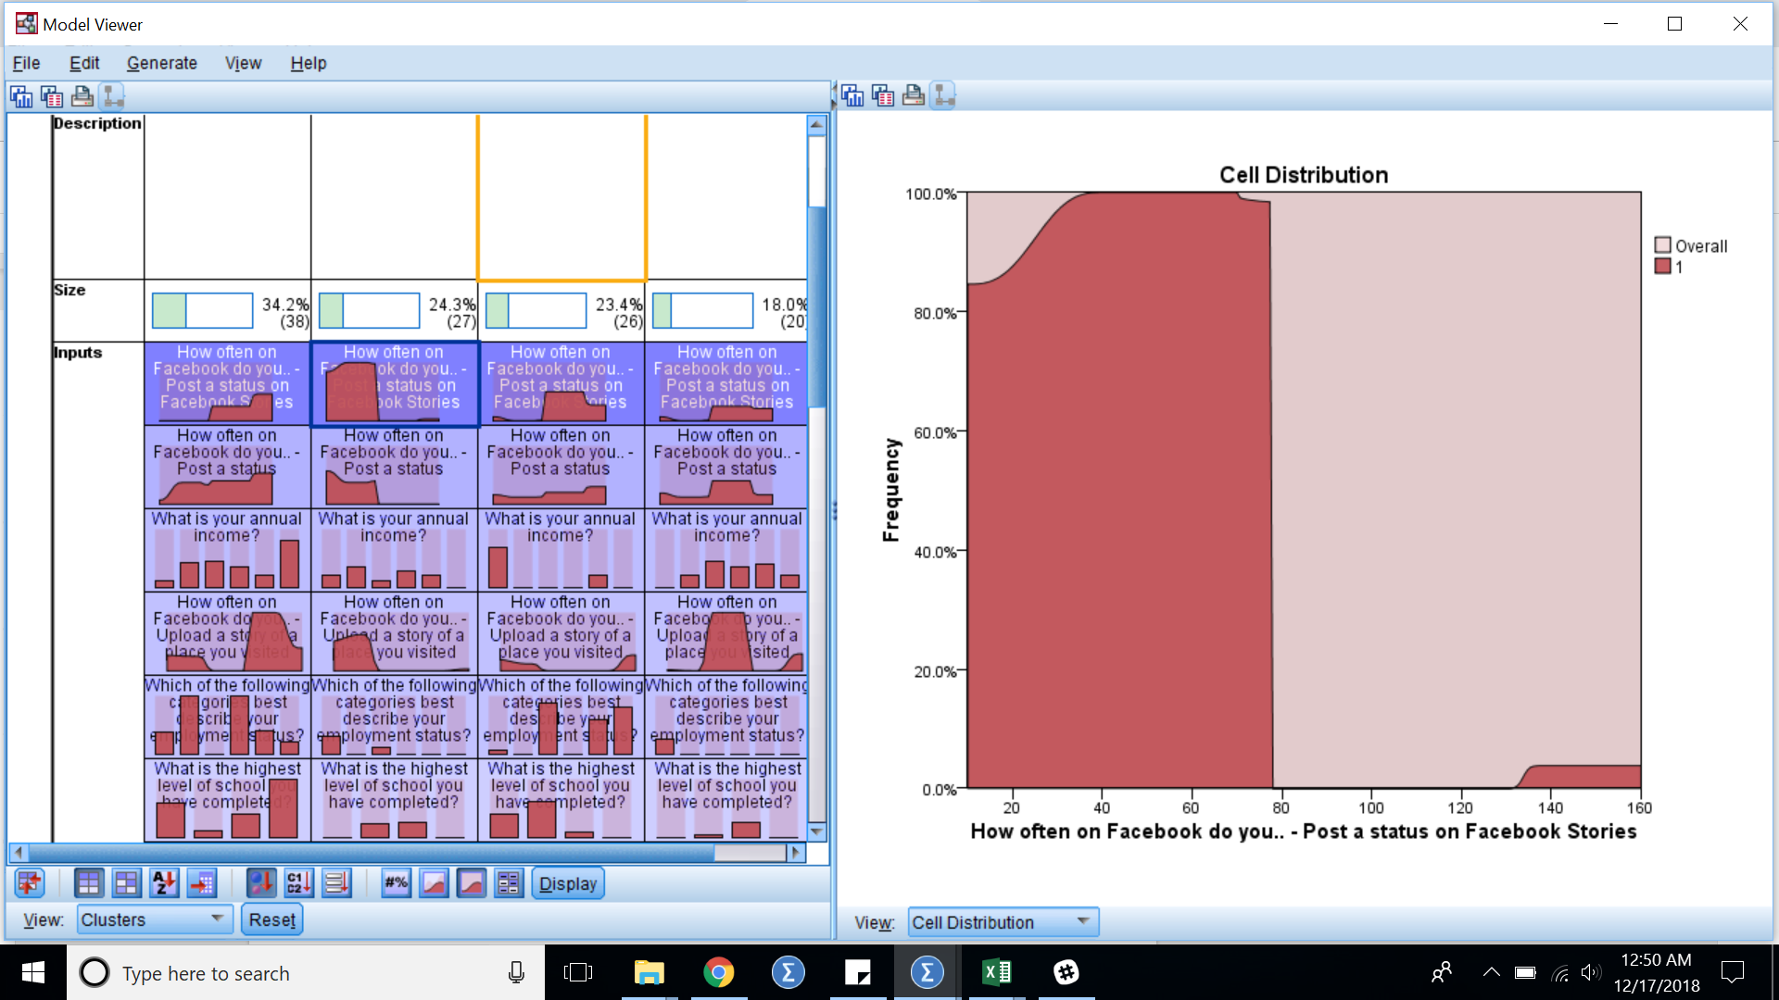

1b.

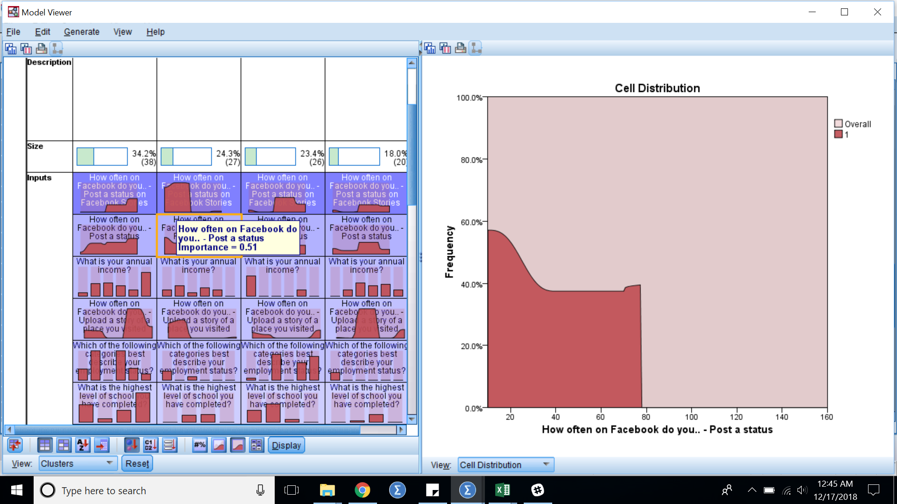

1c.

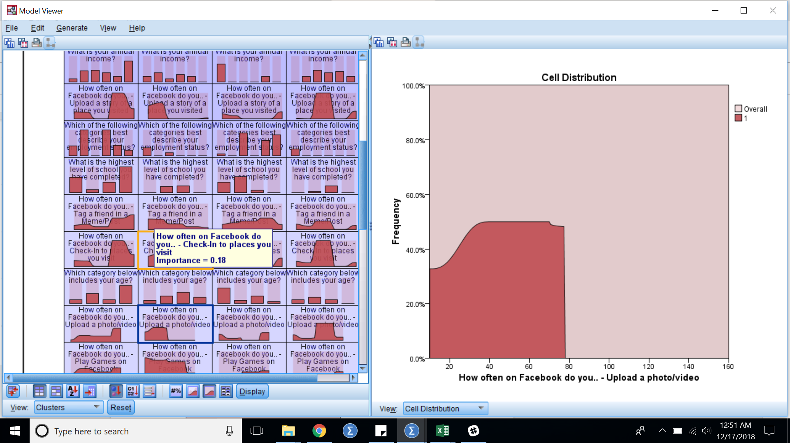

1d.

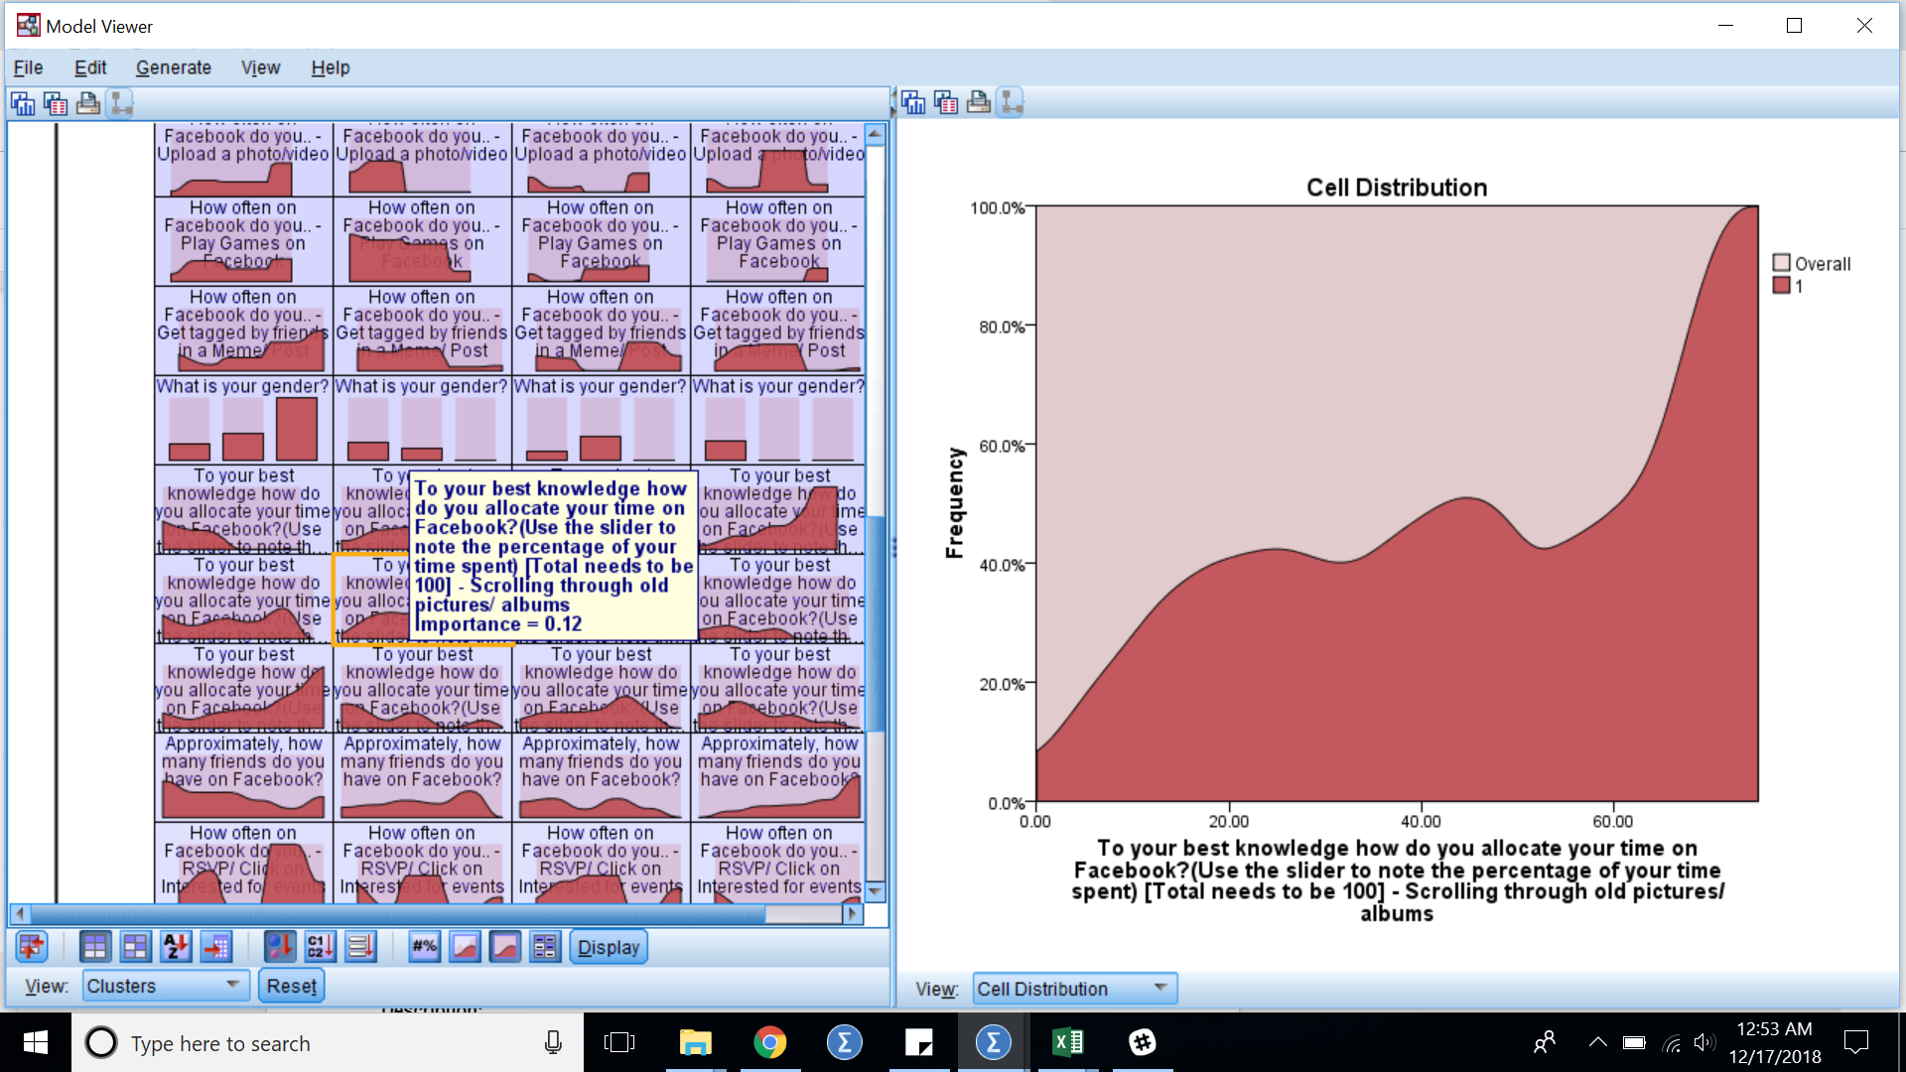

1e.

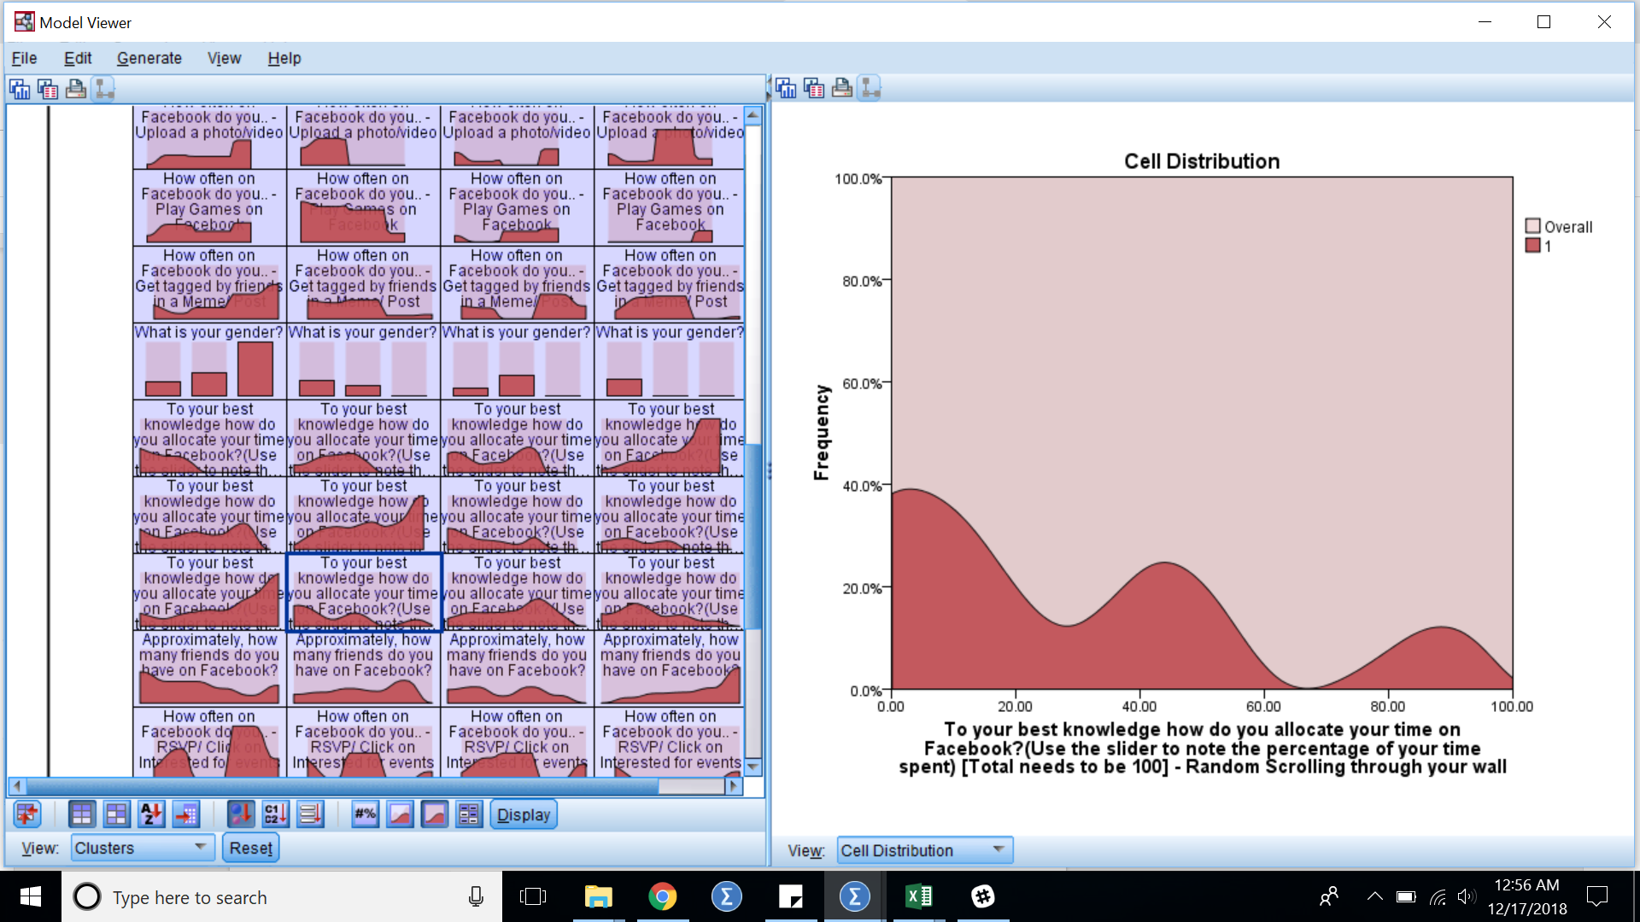

2a.

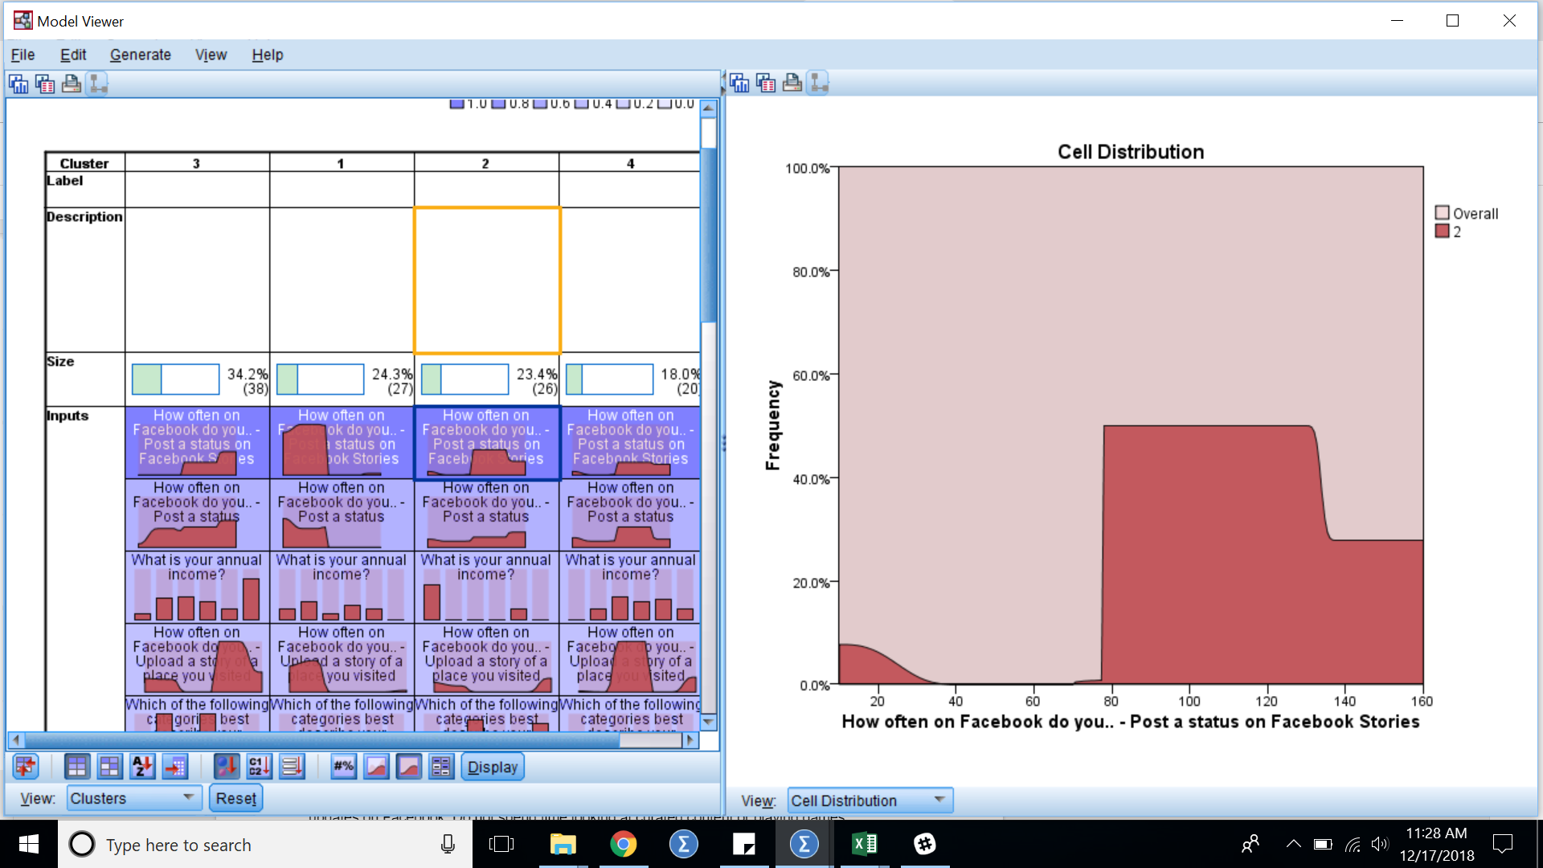

2b.

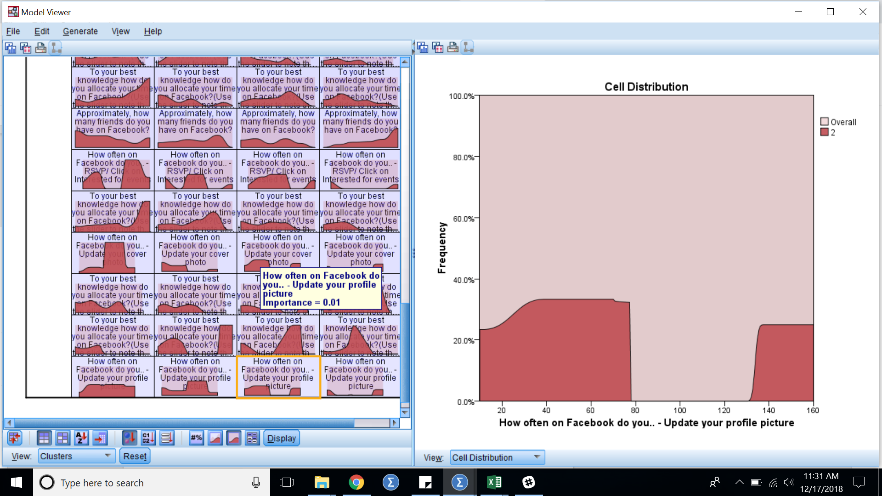

2c.

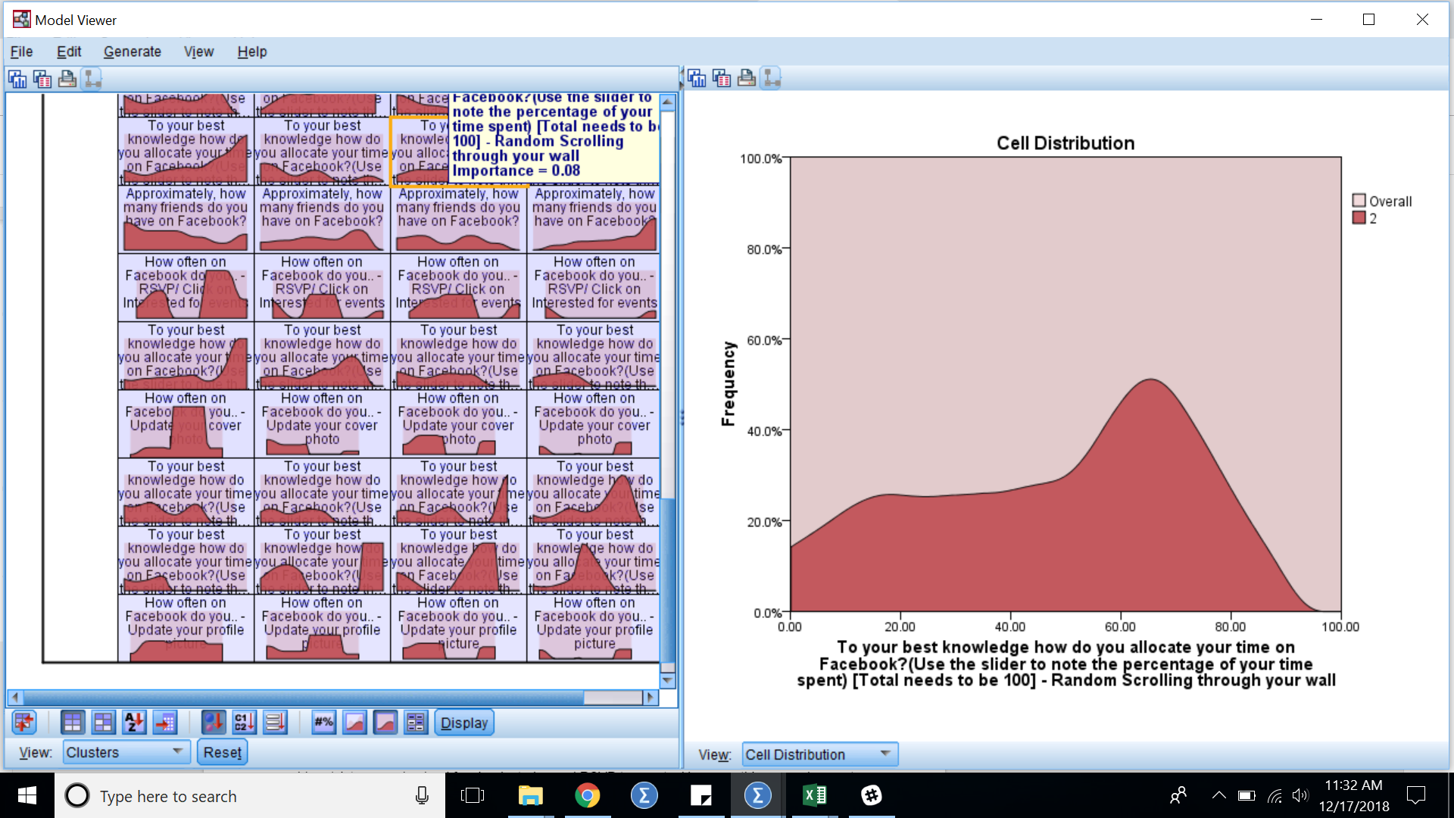

3a.

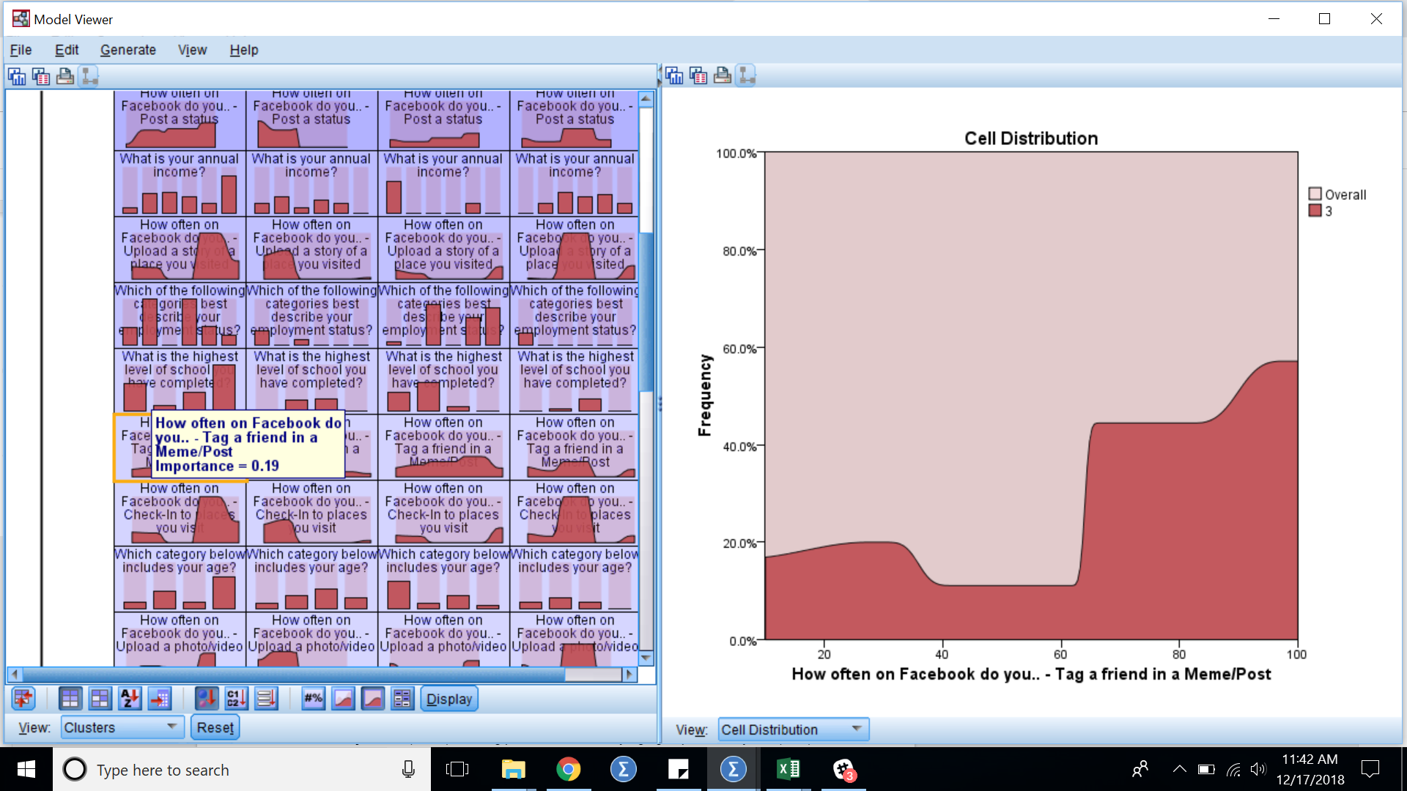

3b.

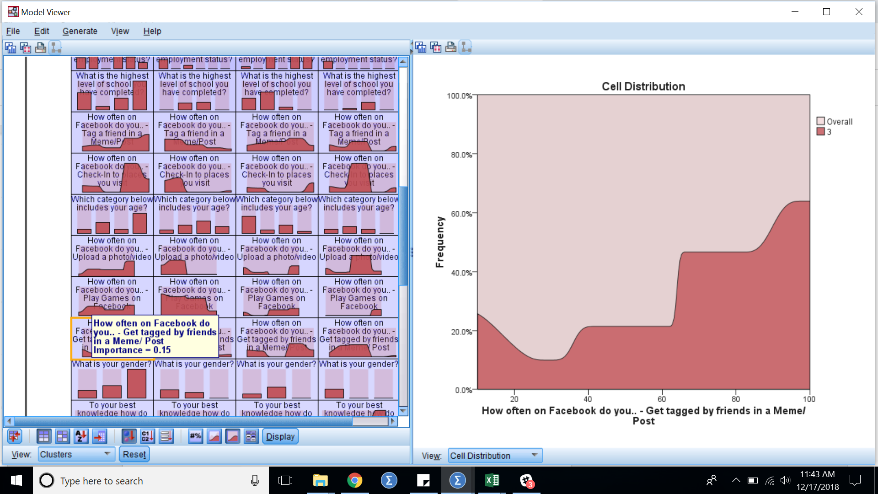

3c.

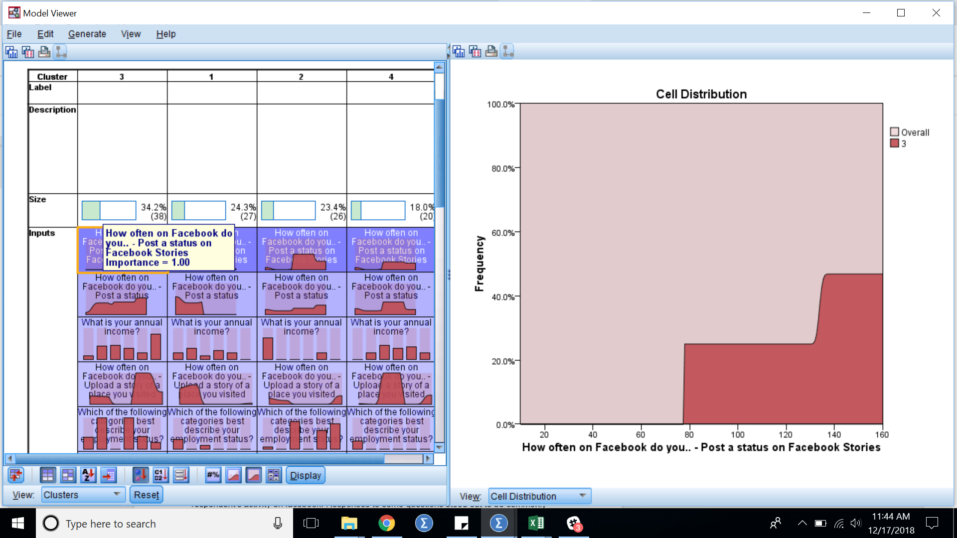

3d.



3e.

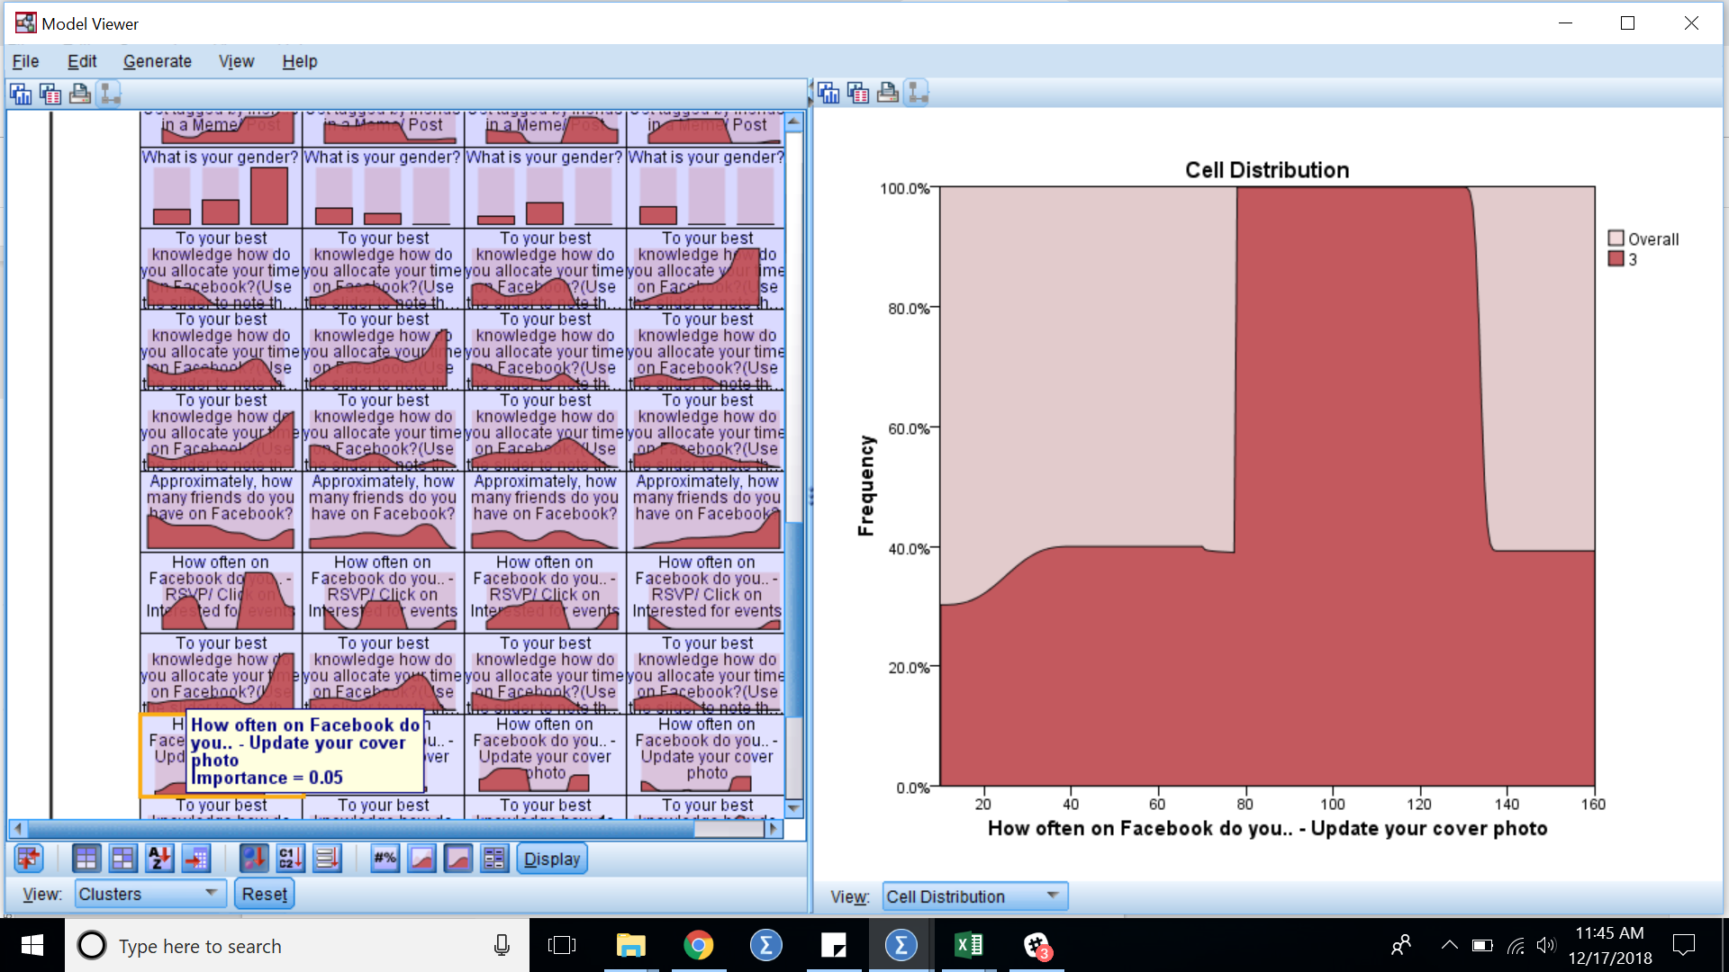

3f.

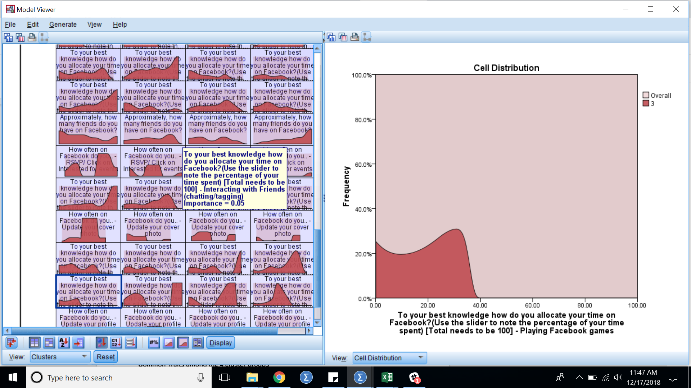

4a.

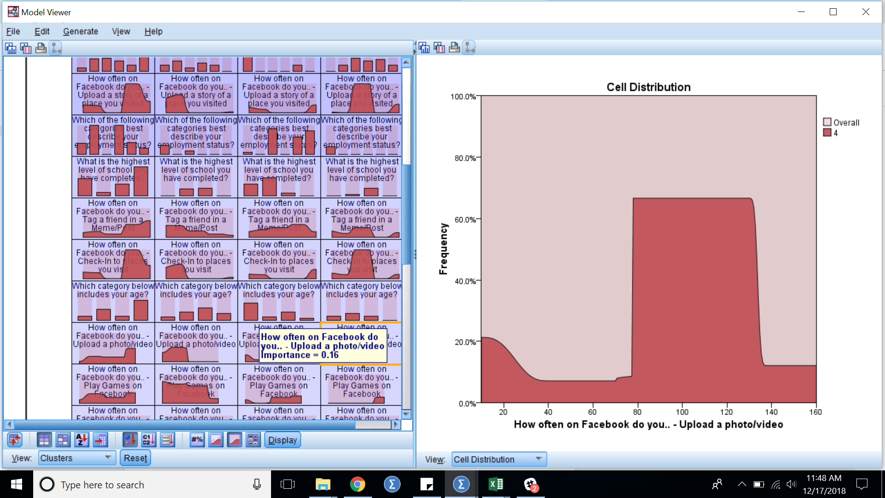

4b.

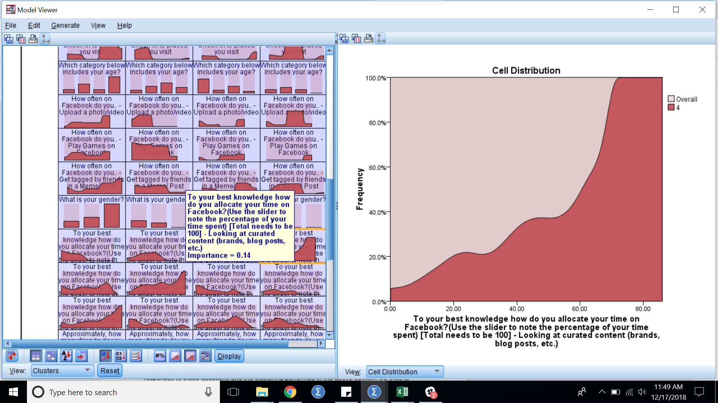

4c.

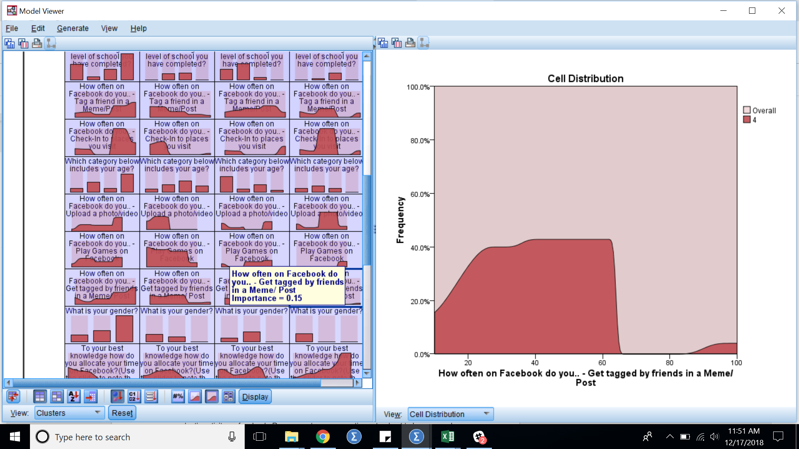

4d.

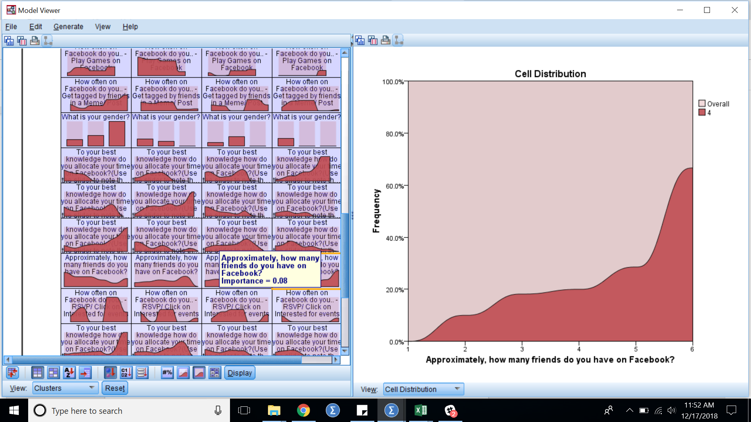

**New Features Introduced in Facebook since Jan 2015.**

|  |  |  |
| --- | --- | --- |
| Sr no | New Facebook Features | Description |
| 1 | AI Chatbot support | Newly introduced AI chat support by facebook makes chat recommendations to its users |
| 2 | Block, snooze | Users can now snooze or block contacts with this handy feature |
| 3 | Conversation starter | Badge given by facebook based on user's activity |
| 4 | Edit Ad Preferences | To curate your ads, go to Settings > Ads > Your Interests. |
| 5 | Facebook birthday calendar new features | Birthday calendar enhanced to view whos b'day from your fiend list is coming in upcoming periods |
| 6 | Face Filters | Facefilters that allows users to enhance their pictures or video calls |
| 7 | Facebook Friendship viewer | Creep on your friend's relationships by looking all time activity together. Type in the URL with the syntax of www.facebook.com/[first name][last name], directly followed by ?and= and followed by the name of the second person. |
| 8 | Facebook Live | People can stream live and interact with their followers on Facebook using Facebook Live option |
| 9 | Facebook Live new features (Popular streams) | Users can view popular live streams on map |
| 10 | Facebook Memories | Facebook summarizes you life events and other activities regularly using facebook memories |
| 11 | Facebook Moments | With Facebook Moments, users can privately sync photos so no one is left out! |
| 12 | Facebook Note | A blogging option that consumers can use within Facebook ecosystem like Medium |
| 13 | Facebook romance | If you want to see the detailed internet history of you and your significant other, go to www.facebook.com/us, and you will see the complete Facebook history with whomever you are listed as in a relationship with |
| 14 | Facebook Stories | Facebook introduced facebook story for quick sharing and also has popular stories of the day section |
| 15 | Facebook Townhall | Facebook Town Hall will tell you your local reps and executives based on your address, and provide one-click access to follow each politician's page There is an option to turn on a "constituent badge," which will mark you as a constituent whenever you comment on your rep's page |
| 16 | Facebook Virtual Arcade | facebook's arcade is where you can play multiplayer games with anyone |
| 17 | Facebook Watch Section (Curated videos) | Similar to youtube, Facebook has a Facebook watch with curated content and has a most popular section and provides batches to top influencers and fans |
| 18 | Facefilter games | Within the facefilter section users can play games to have fun |
| 19 | Find all photos liked by | Using the search bar on facebook if you start typing 'photos liked by', you can see all the pictures searched by the particular person |
| 20 | Games in groups | Users in one group can play a multiplayer instant game |
| 21 | Group Video Chat | Upto 50 people can group video chat with FB |
| 22 | Interest Lists | lets you organize what you see on Facebook so you don't get distracted by all the noise rushing across your News Feed. |
| 23 | Legacy Contact | Facebook lets you name a legacy contact who will manage your account after you are gone.Your legacy contact can write a pinned post for your profile, respond to new friend requests or update your profile and cover photo. They can even download your Facebook data, minus any messages you sent/received. You can also just opt to have your account deleted after you die. |
| 24 | Make a Fund raiser | Users can create a fund raiser pages and ask their friends to help out for a good cause |
| 25 | Messenger day | this app it appeared like biggest competitor against Instagram Stories and Snapchat. However, few features like stickers, filters and posts disappearing within 24 hours etc are also same as that of other competing platforms. |
| 26 | Mood faces | Lets you create faces based on your mood and engage with other users |
| 27 | Privacy chats | Encrypted chats functionality introduced by facebook to keep the chats secure |
| 28 | Recommendations Section (Groups/Events) | Facebook has a recommendations section based on user's interests |
| 29 | Rising star | Badge given by facebook based on users growth in followers |
| 30 | Save posts for later | You can how save important posts to read for later using this option |
| 31 | See First | This feature allow you to designate what people and pages you want to see at the top of the News Feed any time you log in -- on mobile or desktop. |
| 32 | Stop with the birthdays | Facebook has an option to turn of notifications for people's birthdays |
| 33 | Top fan | Badge given by facebook to users based on their activity in the groups they follow |

1. <https://www.socialmediatoday.com/news/the-history-of-social-media-infographic-1/522285/>
2. <https://www.statista.com/statistics/433871/daily-social-media-usage-worldwide/>
3. We Are Social. "Most Famous Social Network Sites Worldwide as of October 2018, Ranked by Number of Active Users (in Millions)." *Statista - The Statistics Portal*, Statista, www.statista.com/statistics/272014/global-social-networks-ranked-by-number-of-users/, Accessed 25 Nov 2018
4. <https://www.fastcompany.com/90248060/report-people-keep-spending-less-and-less-time-on-facebook>
5. <https://www.nytimes.com/2016/05/06/business/facebook-bends-the-rules-of-audience-engagement-to-its-advantage.html>
6. eMarketer. "Number of Social Media Users Worldwide from 2010 to 2021 (in Billions)." *Statista - The Statistics Portal*, Statista, www.statista.com/statistics/278414/number-of-worldwide-social-network-users/, Accessed 25 Nov 2018
7. J. Nielsen, Participation inequality: Encouraging more users to contribute, Nielsen Norman Group (2006), http://www.nngroup.com/articles/participation-inequality/, last accessed on 28 August 2012.
8. J. Radoff, Energize Your Business with Social Media Games (Wile Publishing Inc, Indianapolis, USA, 2011).
9. B. Reeves and J. L. Read, Total Engagement (Harvard Business Press, USA, 2009).
10. Deterding, S., Dixon, D., Khaled, R., & Nacke, L. (2011). From Game Design Elements to Gamefulness: Defining “Gamification”. Paper presented at the 15th International Academic MindTrek Conference, Tampere. <http://dx.doi.org/10.1145/2181037.2181040>.
11. <https://trends.google.com/trends/explore?date=all&q=gamification>
12. <https://www.researchgate.net/publication/256743509_Does_Gamification_Work_-_A_Literature_Review_of_Empirical_Studies_on_Gamification>
13. <http://jultika.oulu.fi/files/nbnfioulu-201405281545.pdf>
14. <https://arxiv.org/ftp/arxiv/papers/1305/1305.2091.pdf>
15. https://www.statisticssolutions.com/cluster-analysis-2/